Centennial College

COMP 228: Java Programming
LAB #4 – Developing UI using JavaFx
FULL MARKS: 100

Student: _____________________________________________________________________

Due Date: Week 10.
Purpose: The purpose of this Lab assignment is to:
- Practice the use of JavaFx GUI event handling

References: Learning materials for weeks 7 and 8, textbook, and other references (if any)

Be sure to read the following general instructions carefully:
This lab should be completed individually by all the students.

YOU NEED TO SUBMIT THE FOLLOWING 2 DOCUMENTS IN THE DROPBOX TITLED LAB4:

- THE FIRST ONE IS A WORD DOCUMENT. USE THIS DOCUMENT AND ADD SCREEN SHOTS OF THE RUNNING STATE OF EACH EXERCISE (If there are more than 1 exercise). DO NOT DELETE THE QUESTIONS. THE SCREEN SHOTS SHOULD FOLLOW EACH QUESTION AND COVER ALL THE ASPECTS/FUNCTIONALITIES OF EACH EXERCISE. AFTER THE SCREEN SHOTS PLEASE COPY THE CODE FROM THE CODE WINDOW AND PASTE THE COMPLETE CODE. DO NOT GIVE ME SCREEN SHOTS OF THE CODE. DO NOT ZIP THIS FILE AND KEEP IT SEPARATE FROM YOUR ZIPPED PROGAM FILE.

- SUBMIT ALSO ONE ZIPPED PROJECT FILE THAT CONTAINS ALL THE EXERISES SEPARATELY INTO THE SAME DROP BOX.

- IF YOU DO NOT DROP BOTH THE DELIVERABLES IN THE DROP BOX, YOUR SUBMISSION WILL BE CONSIDERED AS AN INCOMPLETE SUBMISSION. IN THAT CASE, YOU WILL BE GRADED ON 50% OF THE FULL MARKS.

This material provides the necessary information you need to complete the exercises.

You must name your Eclipse project according to the following rule:

YourFullName_COMP228Labnumber
Example: JohSmith_COMP228Lab4

Each exercise should be placed in a separate package named exercise1, exercise2, etc.

Submit your assignment in a zip file that is named according to the following rule:
YourLastName_COMP228Labnumber.zip
Example: JohSmith_COMP228Lab4.zip

Apply the naming conventions for variables, methods, classes, and packages:
- variable names start with a lowercase character
- classes start with an uppercase character
- packages use only lowercase characters
- methods start with a lowercase character

Exercise 1

Write a Java application using JavaFx which allows the user to enter student information (see the sample design shown in the next page).

The user will enter full name, address, city, province, postal code, phone number and email in text field controls. The student’s major (Computer Science or Business) will be selected from two radio buttons.

A combo box will display the list of courses for each program whenever the user selects the desired program.

A course will be added to a list box whenever the user selects a course from the corresponding combo box. Make sure that the user cannot add a course several times.

Additional information about the student will be provided from a group of check boxes (such as involvement in various activities, etc).

All the information about the student will be displayed in a text area component. Use simple JavaFX layout managers, such as FlowPane, BorderPane, and GridPane to create the JavaFX GUI of this application.

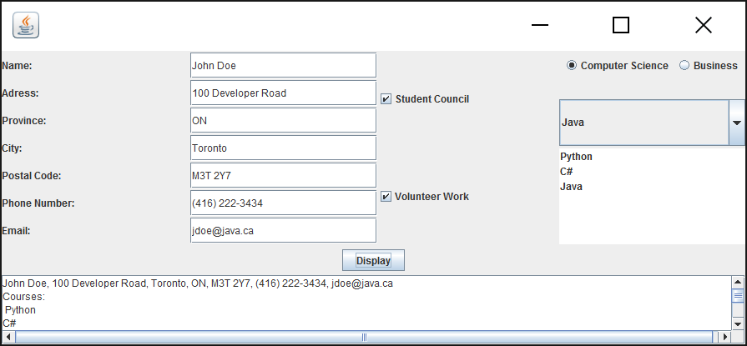

Evaluation:
Functionality
Correct implementation of UI | 40%
Correct implementation of event handling and display of results | 40%
Comments, correct naming of variables, methods, classes, etc. | 5%
Friendly input/output | 15%
Total | 100%

